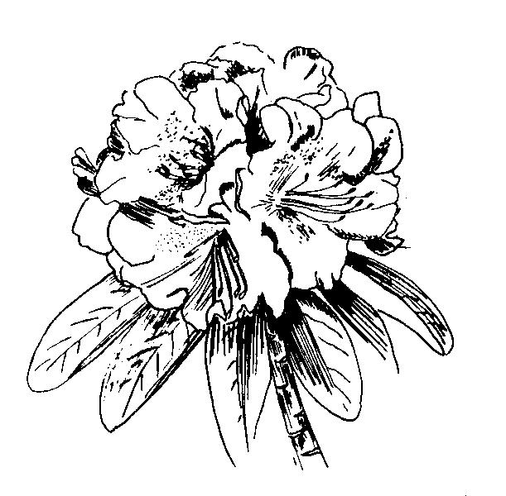
AMERICAN
RHODODENDRON

SOCIETY

Application for Membership

Name__________________________________

Address________________________________

City/State_______________________________

Zip/Country_____________________________

Telephone______________________________

Fax____________ E-mail__________________

MEMBERSHIPS ARE ON A CALENDAR YEAR
Membership includes chapter membership
Student (include proof if over 18)........$10.00
Individual/Family..………………............40.00
Commercial/Corporate………….…..…..90.00
Sustaining……………………….…...…..75.00
Sponsoring…………………….….…… 150.00
Life, single………………….….….…..1,000.00
Life, family………………….….….…..1,500.00
I would like my “home” chapter to be:
____________________________________
_______________________________
In addition to the above “home” chapter, you may wish to belong to other chapters as an ASSOCIATE MEMBER. List those chapters here and enclose an additional $10/chapter:
__________________________________________________________________________________

Credit card no.________________________________
Expiration date___________________
Signature____________________________________

Or, send this form with US Funds drawn on a US Bank, payable to:
AMERICAN RHODODENDRON SOCIETY
P.O. Box 525
Niagara Falls, NY 14304-0525

Phone (416) 424-1942, Fax (905) 262-1999
Email: lauragrant@arsoffice.org
Website: www.rhododendron.org

AMERICAN
RHODODENDRON

SOCIETY

Application for Membership

Name__________________________________

Address________________________________

City/State_______________________________

Zip/Country_____________________________

Telephone______________________________

Fax____________ E-mail__________________

MEMBERSHIPS ARE ON A CALENDAR YEAR
Membership includes chapter membership
Student (include proof if over 18).........$10.00
Individual/Family..……………….............40.00
Commercial/Corporate………….…..…..90.00
Sustaining………………………..…...…..75.00
Sponsoring…………………….….…… 150.00
Life, single………………….….….…..1,000.00
Life, family………………….….….…..1,500.00
I would like my “home” chapter to be:
____________________________________
_______________________________
In addition to the above “home” chapter, you may wish to belong to other chapters as an ASSOCIATE MEMBER. List those chapters here and enclose an additional $10/chapter:
__________________________________________________________________________________

Credit card no.________________________________
Expiration date___________________
Signature_____________________________________

Or, send this form with US Funds drawn on a US Bank, payable to:

AMERICAN RHODODENDRON SOCIETY
P.O .Box 525
Niagara Falls, NY 14304-0525

Phone (416) 424-1942, Fax (905) 262-1999
E-mail: lauragrant@arsoffice.org
Website: www.rhododendron.org

AMERICAN
RHODODENDRON

SOCIETY

Application for Membership

Name__________________________________

Address________________________________

City/State_______________________________

Zip/Country_____________________________

Telephone______________________________

Fax____________ E-mail__________________

MEMBERSHIPS ARE ON A CALENDAR YEAR
Membership includes chapter membership
Student (include proof if over 18)........$10.00
Individual/Family..………………............40.00
Commercial/Corporate………….…..…..90.00
Sustaining……………………….…...…..75.00
Sponsoring…………………….….…… 150.00
Life, single………………….….….…..1,000.00
Life, family………………….….….…..1,500.00
I would like my “home” chapter to be:
____________________________________
_______________________________
In addition to the above “home” chapter, you may wish to belong to other chapters as an ASSOCIATE MEMBER. List those chapters here and enclose an additional $10/chapter:
__________________________________________________________________________________

Credit card no.________________________________
Expiration date___________________
Signature_____________________________________

Or, send this form with US Funds drawn on a US Bank, payable to:

AMERICAN RHODODENDRON SOCIETY
P.O. Box 525
Niagara Falls, NY 14304-0525

Phone (416) 424-1942, Fax (905) 262-1999
E-mail: lauragrant@arsoffice.org
Website: www.rhododendron.org

